**ARYAMAN MISHRA**

**19BCE1027**

**SAMPLE PROGRAM**

#include "mpi.h"

#include <stdio.h>

#include <stdlib.h>

float *create_rand_nums(int n)

{

float *rnd=(float *) malloc(sizeof(float)*n);

int i;

for(i=0;i<n;i++)

{

rnd[i]=rand();

}

return rnd;

}

int main(int argc, char *argv[])

{

MPI_Init(&argc,&argv);

int id;

int p,i;

int num_elements_per_proc=1;

MPI_Comm_rank(MPI_COMM_WORLD, &id);

MPI_Comm_size(MPI_COMM_WORLD, &p);

float *rand_nums = NULL;

if(id==0)

{

rand_nums = create_rand_nums(p);

}

float *sub_rand_nums = (float *)malloc(sizeof(float) * p);

MPI_Scatter(rand_nums, num_elements_per_proc, MPI_FLOAT, sub_rand_nums, 1, MPI_FLOAT, 0, MPI_COMM_WORLD);

if(id>0)

{

printf("\nData recieved: ");

for( i=0;i<p;i++)

{

printf("%.2f ",sub_rand_nums[i]);

}

printf("\n");

}

MPI_Finalize();

return 0;

}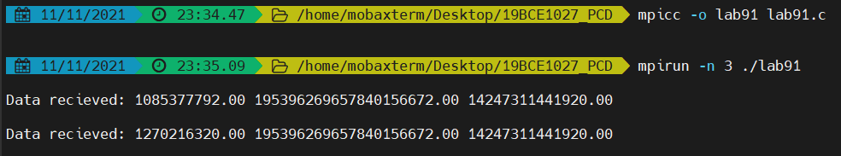

**Create a random number and broadcast to each other by using Gather Function.**

#include "mpi.h"

#include <stdio.h>

#include <stdlib.h>

float *create_rand_nums(int n)

{

float *rnd=(float *) malloc(sizeof(float)*n);

int i;

for(i=0;i<n;i++)

{

rnd[i]=rand();

}

return rnd;

}

int main(int argc, char *argv[])

{

MPI_Init(&argc,&argv);

int id;

int p,i;

int num_elements_per_proc=1;

MPI_Comm_rank(MPI_COMM_WORLD, &id);

MPI_Comm_size(MPI_COMM_WORLD, &p);

float *rand_nums = NULL;

if(id==0)

{

rand_nums = create_rand_nums(p);

}

float *sub_rand_nums = (float *)malloc(sizeof(float) * p);

MPI_Gather(&rand_nums, 1, MPI_FLOAT, sub_rand_nums, 1, MPI_FLOAT, 0, MPI_COMM_WORLD);

if(id>0)

{

printf("\nData recieved: ");

for( i=0;i<p;i++)

{

printf("%.2f ",sub_rand_nums[i]);

}

printf("\n");

}

MPI_Finalize();

return **0;**

**}**

